Digital Connoisseurship: Recognizing iconographic themes from fragmentary archaeological ceramic artifacts.

The Moche or Mochica culture of the North Coast of Peru (250-900CE) are celebrated as having developed one of the richest artistic traditions in the Andean region of South America. The Moche are famed for their depictions of every imaginable facet of daily life in ceramic artifacts known as “Stirrup Vessels”, bottle-like objects that were placed in burials as ceremonial offerings. In the absence of a written language, the study of the complex narrative iconography depicted in these objects forms the foundation of our understanding of the cultural dynamics and ritual traditions of this Pre-Columbian society. Tens of thousands of these vessels have become part of museum and private collections in Perú and around the world, and continue to be the focus of considerable scholarship. As these ceramic vessels are quite fragile, complete examples are almost exclusively found in undisturbed tombs, either through scientific archaeological excavation or more sadly, through wide-spread illegal looting activity. More frequently, only fragments (known as sherds) of these vessels are found in archaeological contexts, allowing for an extremely partial understanding of the complete iconography of the original artifact. However, with so many intact examples in museum collections, it is often possible to compare these fragments to known iconographic scenes. The process of assigning a fragment to a particular iconographic scene is entirely dependent on a researcher’s exposure to the artistic corpus, their “connoisseurship” or expert knowledge. The current project aims to test whether machine learning techniques could assist in the recognition of iconographic scenes from fragmentary elements. An initial challenge will involve creating an algorithm that will “break” or “shatter” the reference images into fragments that will be used to train a self-supervised deep learning system. Ideally, once this system is trained, an image of a novel fragment could be introduced to the system, and assigned to a particular complete iconographic scene.

*Moche stirrup vessel with “Presentation Theme” iconography*

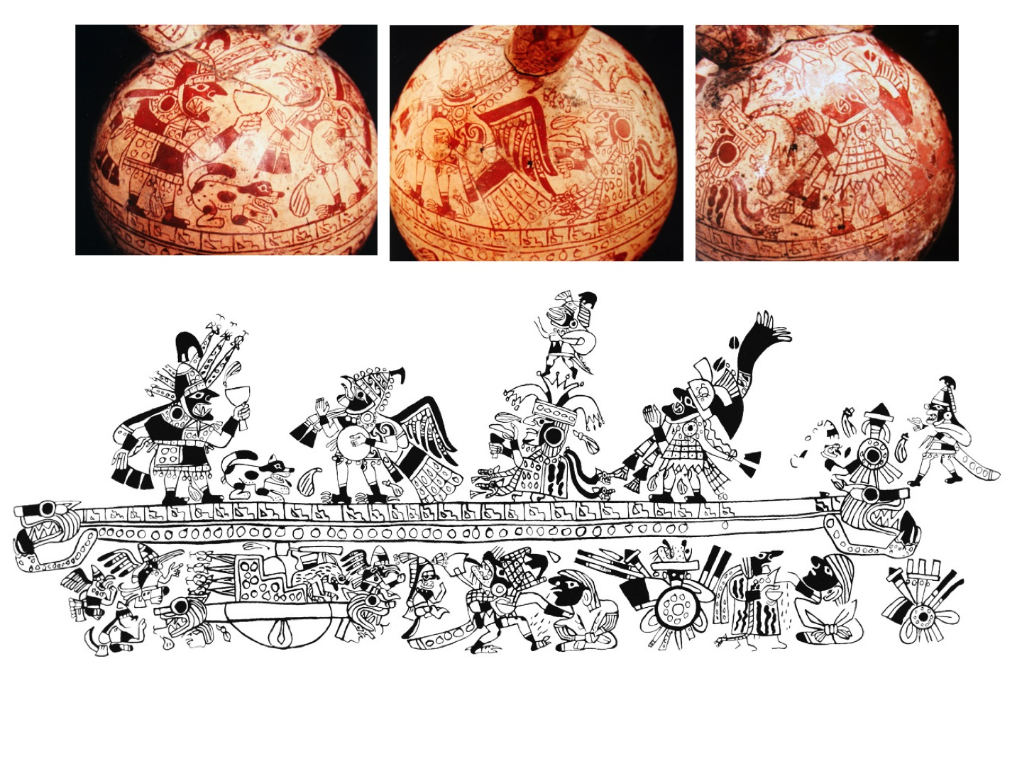

*Details of the “Presentation Theme” iconography and roll-out illustration of the entire scene*

**

*Three sherds from the “Tule Boat Theme”*

**

*Approximate location of the same three sherds within a roll-out illustration of the “Tule Boat Theme”*

*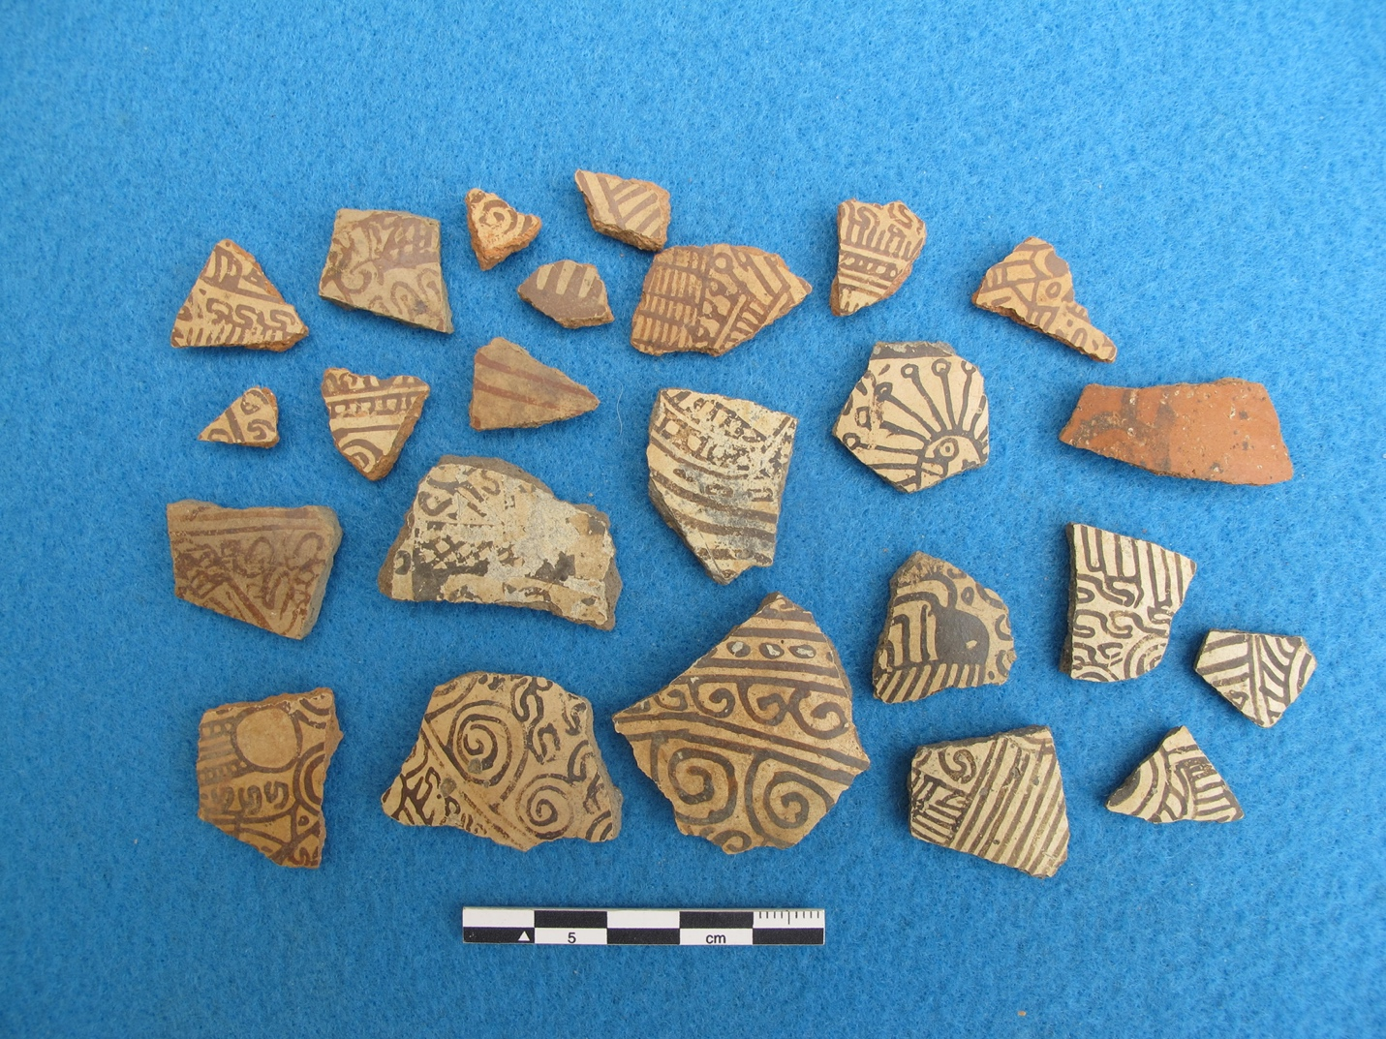*

*Example of the ceramic fragments of stirrup vessels usually found in archaeological excavation*